

**Smog in Bishkek:**

**Myths and Reality**

By:

Kanat Sultanaliev,

Rahat Sabyrbekov,

Zheenbek Kulenbekov

August 2021

**Institution Affiliation**

This research was carried out with a grant provided by the American University of Central Asia for the purpose of conducting research on the issue of air quality in Bishkek city, the Kyrgyz Republic.

Kanat Sultanliev is an Executive Director of the Tian Shan Policy Center at the American University of Central Asia. His research interests are broad and include key topics related to sustainable development.

Dr. Rahat Sabyrbekov is post-doc researcher at the OSCE Academy and taught many years at Economics program at AUCA. He specializes in environmental economics.

Dr. Zheenbek Kulenbekov is an Associate Professor and Head of Applied Geology Department at American University of Central Asia. He focuses on environmental safety including hydrology studies, water quality monitoring, and environmental impact assessment.

**Disclaimer**

This report is the work of Kanat Sultanaliev, Dr. Rahat Sabyrbekov, and Dr. Zheenbek Kulenbekov, and does not necessarily reflect the views or values of the American University of Central Asia nor the stance of any department or office at the American University of Central Asia.

**Abstract**

Main objective of the research is to improve current understanding of the causes and impacts of the winter air pollution in Bishkek. Analysis of the extreme pollution events in Bishkek during the observed period showed that the impact of the climatic conditions on air pollution level in Bishkek is very significant.

Based on the inventories of air pollution in other countries and approximate quantification of the major PM2.5 sources in Bishkek, we came up to the following estimates:

* The source contributing most to anthropogenic PM2.5 pollution in Bishkek during the average heating season is “Households and other buildings not connected to CHP”;
* Next most important source is CHP. However, it is difficult to estimate how much CHP contributes to the PM2.5 levels in Bishkek without detailed information on the effectiveness of the emission control system installed at the plant;
* Third most important source of the PM2.5 winter pollution is road transport.

The coal-based emission has increased by 22% in last six years. The coal consumption has been increasing and the data shows that this growth trend has been stable.

**Table of contents**

**List of abbreviations** 6

**List of tables** 7

**List of figures** 7

**Research outline** 8

**Changes made** 9

**Work completed** 10

Cost of Air Pollution 29

**Conclusions** 32

**Bibliography** 35

**Annexes** 37

# **List of abbreviations**

|  |  |
| --- | --- |
| ADB | Asian Development Bank |
| AQI | Air Quality Index |
| CHP | Central Heat and Power Plant |
| DAQI | Daily Air Quality Index |
| EPA | United States Environmental Protection Agency |
| HCOH | Formaldehyde |
| IEA | International Energy Agency |
| KIHS | Kyrgyz Integrated Households’ Survey |
| KRSU | Kyrgyz Russian Slavonic University |
| NOx | Mono-nitrogen oxides – nitric oxide and nitrogen dioxide |
| NSC | National Statistics Committee of Kyrgyzstan |
| PA | Public Association |
| PM | Particulate Matter |
| PM2.5  PM10 | Particulate matter with diameter less than 2.5 microns  Particulate matter with diameter less than 10 microns |
| US  USA | United States  United States of America |
| VSL | Value of Statistical Life |
| µg | Microgram, one millionth (1×10−6) of a gram |

# 

# **List of tables**

Table 1: AQI Scale and related PM concentrations 12

Table 2: DAQI Scale and related PM concentrations 12

Table 3: Average temperatures in Bishkek and Baitik stations 14

Table 4: Extreme PM2.5 pollution and related climatic parameters 15

Table 5: Air pollution and climatic parameters before/after key events 19

Table 6: Average PM2.5 concentrations on and off heating season in Bishkek 22

Table 7: The content of carbon monoxide in the exhaust of petrol cars 23

Table 8: Smokiness of the exhaust of diesel cars 24

Table 9: Total and mean consumption of energy products 27

Table 10: Coal consumption and emissions 28

Table 11: Calculation of VSL for Kyrgyzstan 31

Table 12: VSL-based annual air pollution cost from number of deaths 31

**List of figures**

Figure 1: Monthly PM2.5 concentrations and temperature in Bishkek 17

Figure 2: PM2.5 conc-s and difference in t℃ b/n Bishkek and Baitik 18

Figure 3: Average hourly PM2.5 concentrations 21

Figure 4: Winter smog in Bishkek (picture from sputnik.kg website) 22

Figure 5: Total consumption of energy source by households by KIHS 26

Figure 6: Per household CO2 emission from coal consumption 29

Figure 7: Steps in cost-benefit analysis 30

Figure 8: PM2.5 emission sources in Europe 33

Figure 9: Relative PM2.5 emissions in USA 33

# 

# **Research outline**

The air pollution situation in Bishkek in the recent winter periods was unprecedented. For significant periods of time, the Air Quality Index of Bishkek city topped the global air quality index (AQI) rankings. Local sensors registered several days where readings exceeded 500 µg for PM2.5, much higher than the hazardous level of 300 µg. Air pollution is a major threat to human health and a leading cause of death and disease globally. An estimated 7 million premature deaths globally are linked to air pollution, mainly from heart disease, stroke, chronic obstructive pulmonary disease, lung cancer, and acute respiratory infections (WHO 2016). Kyrgyzstan is among the countries affected by this crisis. Data from the Kyrgyz Hydrometeorological Service (Kyrgyzhydromet) and independent researchers confirm that during the winter months, the concentration of dangerous air pollutants such as fine particulate matter (PM2.5) and nitrogen oxides in Bishkek regularly exceeds WHO guidelines and Kyrgyz Government target values. Frequent temperature inversions in Bishkek contribute to exacerbating the problem. In recent months, several episodes of extremely high concentrations have landed Bishkek at the top of the AirVisual ranking for the cities with the worst air quality around the world ([iqair.com](http://www.iqair.com)). Cases of child asthma and respiratory disease related morbidity increase annually (NSC 2020). Independent research on air pollution in Kyrgyzstan has been carried out by researchers at different universities and civil society organizations since the early 2010s.

Data on PM2.5 is available from a growing network of independently operated low-cost sensors, which are however of uncertain quality. In February 2019, the US Embassy installed a high quality Beta Attenuation Monitor on its premises and is making data available online at [www.Airnow.gov](http://www.airnow.gov) for analysis. Data on PM2.5 from low-cost monitors installed around Bishkek by civil society and private individuals is available also online through a platform with open environmental data specialising on air quality data called [www.Sensor.Community](http://www.sensor.community) (previously known as [www.Luftdaten.info](http://www.luftdaten.info)). Several private organizations around Bishkek have installed PM2.5 sensors on their premises and the data is available through the websites of sensor manufacturers such as Purple Air. However, there is no quality control of the data from these individual sensors. Data on other pollutants such as nitrous oxides, sulphur dioxide, and ground level ozone is only available from individual sensors of Kyrgyzhydromet and KRSU. Recently, Public Association Movegreen in partnership with KyrgyzHydromet has launched a new platform [www.aq.kg](http://www.aq.kg) where air pollution and climatic data from multiple sensors is available in real-time mode. However, historical data is not yet accessible. The research team obtained available data and conducted analyses to provide insights into the levels and the frequency of pollution events, as well as the key factors leading to winter air pollution in Bishkek.

The problem with winter air pollution is a regular subject for active public discussions in Bishkek for the last several years. To date, there is no clear understanding of the major sources of the pollution, as there are divided opinions on that among stakeholders and experts. Currently, data on air quality comes from many sources, including low-cost monitors as well as professional sensors. All of them show very high level of air pollution in Bishkek during winter months. However, there are still many gaps in the analysis of this problem. Our research will build on accumulated data and knowledge, but will make further steps forward in answering specific questions that were not answered yet.

In the beginning of 2021, PA Movegreen and environmental activist Pavel Isaenko published new reports which highlighted significance of the thermal inversions in the winter smog formation in Bishkek. Thus, Movegreen report for the winter season of 2020-2021 (Movegreen 2021a) indicated that PM2.5 average daily concentrations in December 2020 and January 2021 exceeded the respective Kyrgyz standards in the range from 8 to 12 times. NO2 average monthly concentrations were 1.2 to 3.5 times higher than should be. Especially high concentration were observed in the town center where monthly concentrations of NOx and HCOH were exceeded for up to 6 times. Highest PM concentrations were observed during the timeslot from 18.00 till 01.00. In other report (Movegreen 2021b) it was noted that the periods of highest PM concentrations coincided with the days with average temperature colder than -5, leading to suggestion that cold spells could be linked with cases of smog. Pavel Isaenko (Isaenko 2021) also suggested that the geographical and meteorological features of the Chuy valley play a tangible role in Bishkek’s predisposition for air pollution. Earlier Oleg Podrezov (Podrezov 2018) revealed that winter meteorological conditions in Bishkek are very conducive for smog.

Main objective of the current research is to improve the understanding of the causes and impacts of the winter air pollution in Bishkek. In particular, our research will look at the following major questions:

1. What is the correlation between the temperature inversions and cases of high levels of air pollution in Bishkek?
2. Which of the major winter air pollution sources (Central Heat Plant, vehicles, households’ heating) are the most important factors in winter smog?
3. What are the economic costs of air pollution in Bishkek?

# **Changes made**

During the research activities no major alterations from the proposed research outline were made. However, field measurements of the vehicle emissions from their tailpipes were not implemented due to reluctance of the laboratories’ personnel and technical difficulties to conduct such measurements. Instead, research team agreed to get access to the existing data on vehicle emissions. Such approach proved to be more effective both time wise and logistically.

# **Work completed**

Desk review

In general, there are not many publications on air pollution in Kyrgyzstan. The bulk of the materials were published in Russian. Therefore, all the relevant recent publications on the topic of air pollution in Bishkek were checked by the research team to delve deeper into the study topics and understand the current gaps in the knowledge and research. Thus, most recent Movegreen reports, publications of Oleg Podrezov from the Kyrgyz Russian Slavonic University, and civil environmental activist Pavel Isayenko were downloaded and studied. Latest updates in the news related to air pollution in Kyrgyzstan were also studied thoroughly. The topic of air pollution in Bishkek is quite acute and there are many stakeholders and interested parties with various opinions on the subject.

Activities on data collection

Data collection is one of the main bottlenecks that intricate research activities in the Kyrgyz Republic. We contacted all relevant stakeholders to get available information and data. The following organizations were contacted:

1. National Statistics Committee. They gave us information on number of passenger cars registered in Bishkek, statistics on import of coal in recent years, data on number o households officially registered in Bishkek, share of households using coal and firewook for heating purposes;
2. Database from the Kyrgyz Integrated Household Survey (KIHS) was also purchased from the NSC for three most recent available years – 2017, 2018, 2019 (this database was already share with colleagues from the AUCA economic department). The KIHS database provides in-depth data about households in all regions and towns of the country;
3. Data on quality and quantity of the coal used by Central Heat Plant (ТЭЦ) was received from the JSC “Electric Stations”;
4. Field survey was conducted by AUCA students to estimate average fuel consumption and mileage covered by average Bishkek car drivers. For this survey a short questionnaire was developed by researchers;
5. Data on vehicle emissions were received from the “Kochkortehosmotrservis LLC” (one of the laboratories that conduct measurements of the vehicle emissions in Bishkek). The staff of this laboratory was very cooperative and provided their data on free-of-charge basis. Due to this cooperativeness, there was no need for research team to organize separate field measurements of the vehicle emissions;
6. Meteorological data was acquired with the help of the specialised Russian meteorological platform that provides climatic data on post-soviet countries on free-of-charge basis. In particular, research team downloaded available climatic data for the years 2019, 2020 and 2021 for two weather stations – Bishkek and Baitik;
7. Available air pollution data was screened and the researchers decided to select the sensor installed at the USA Embassy in Bishkek. Data from Kyrgyzhydromet sensor was not easily accessible. ADB-purchased sensors started monitoring only in spring 2021. US Embassy started monitoring of the air pollution in Bishkek in February 2019, therefore our study also focused namely on the period from February 2019 till July 2021.

Conducted analysis

What is the correlation between the temperature inversions and cases of high levels of air pollution in Bishkek?

Contemporary public discussions of the air pollution very often refer to the Air Quality Index (AQI). AQI is relatively new term which was introduced by United States Environmental Protection Agency (US EPA). EPA defines U.S. AQI as a daily color-coded index designed to communicate whether air quality in a given location is healthy or unhealthy for people. AQI for particulate matter is given below (taken from <https://www.airnow.gov/aqi/aqi-basics/> ).



It should be noted that the interconnection between AQI and pollution level from Particulate Matter (PM) is not a straightforward one. The following table is based on EPA reference document (US EPA 2018) and provides detailed correspondence between AQI categories and PM pollution levels:

**Table 1: AQI Scale and corresponding PM concentrations (source: EPA)**

|  |  |  |
| --- | --- | --- |
| **AQI Scale** | **Particulate Matter (µg per cubic meter)** | |
| PM2.5 [24-hour] | PM10 [24-hour] |
| Good (up to 50) | 0 – 12 | 0 -54 |
| Moderate (51 – 100) | 12.1 – 35.4 | 55 - 154 |
| Unhealthy for sensitive groups (101 – 150) | 35.5 – 55.4 | 155 - 254 |
| Unhealthy (151 -200) | 55.5 – 150.4 | 255 - 354 |
| Very unhealthy (201 – 300) | 150.5 – 250.4 | 255 - 424 |
| Hazardous (301 – 500) | 250.5 – 500.4 | 425 - 604 |

Apart from the AQI there are other alternative air quality scales used in the world. One of such alternative air quality scales was developed in the United Kingdom and titled as Daily Air Quality Index (DAQI). DAQI scale is shown below in the Table 2:

**Table 2: DAQI Scale and corresponding PM concentrations (source:** [**https://uk-air.defra.gov.uk/air-pollution**](https://uk-air.defra.gov.uk/air-pollution) **)**

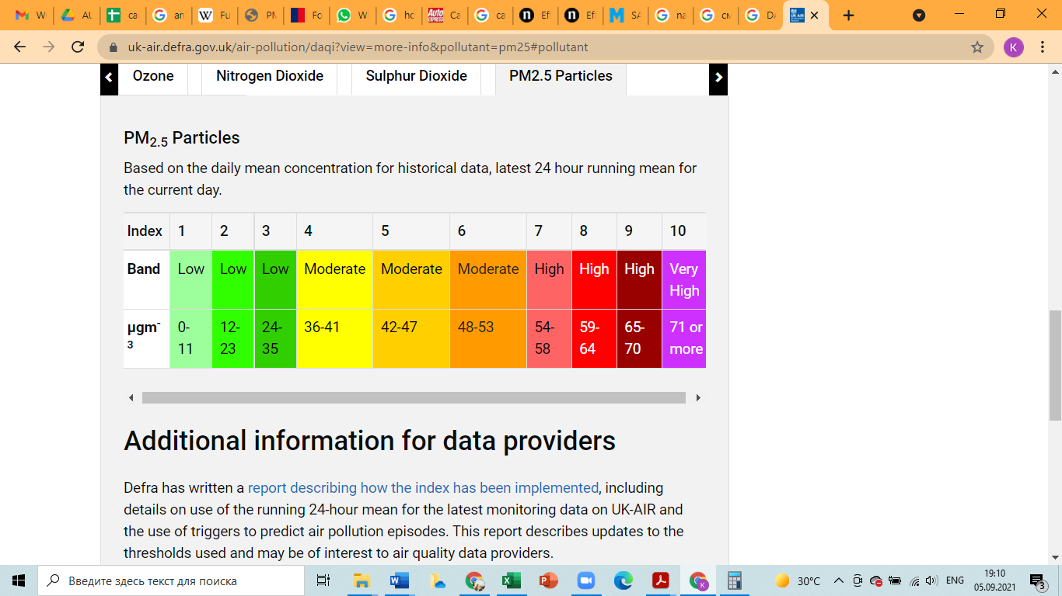

US Embassy sensor data were screened and filtered as follows: PM2.5 hourly concentrations showed in the downloaded Excel file as “invalid”, “missing” and “suspect” were deleted; negative PM2.5 concentrations were replaced by 0 µg. Further analysis of the datasets downloaded from the USA Embassy sensor revealed that winter air pollution levels in Bishkek are extremely high and on a number of occasions the hourly PM2.5 concentrations in Bishkek even exceeded the maximum level of 500.4 µg. Quick analysis showed the following lows and highs of PM2.5 concentrations observed in Bishkek as per USA Embassy sensor data:

In 2019 – the lowest hourly concentration was registered on July 01, 2019 at 07.00 and was equal to 5 µg; the highest hourly concentration was observed on December 17, 2019 at 14.00 and was equal to 753 µg.

In 2020 – the lowest hourly concentration of 0 µg was registered in 832 cases (10 times in winter); the highest hourly concentration was observed on December 22, 2020 at 14.00 and was equal to 785 µg.

In 2021 – the lowest hourly concentration of 0 µg was registered in 14 cases (8 times in winter); the highest hourly concentration was observed on January 03, 2020 at 15.00 and was equal to 917 µg.

To narrow the scope of our analysis we focused only on extreme hourly raw concentrations and namely on cases of highest concentrations exceeding the threshold of 500 µg within the period from 01 October till 30 April in each year from 2019 till 2021 (to date). In 2019 there were registered 4 such cases (all in December), in 2020 there were 5 (also in December), and in 2021 there were 40 cases (all in January).

Our idea was to study these cases of abnormally high pollution levels and to see whether there were observed cases of temperature inversion, before, during and shortly after the extreme air pollution events. Analysis of the average monthly temperatures at two meteorological stations, Bishkek (760 meters above sea level) and Baitik (1580 meters above sea level), was done to understand how temperatures at these two stations relate to each other in various seasons. As the table below shows, in summer the difference between two stations was well above 6.5 ℃ which is normal, as the temperature tends to decrease with elevation (Encyclopedia Britannica 2021). However, in winter this difference dropped very drastically and in January 2021 the difference became even negative, meaning that the average daily temperatures in Baitik were warmer than in Bishkek (interestingly, namely January 2021 was the month when there were registered 40 out of 49 cases of extreme winter pollution since February 2019). Such unusual situation with the negative temperature difference between Bishkek and Baitik could be explained only by the influence of the thermal inversion – a natural meteorological phenomenon when the lowest layer of the air (the part of the atmosphere that is closest to the ground) becomes colder than the upper layers of air, whilst in normal conditions the near-ground air should be warmer than the upper air layers (Encyclopedia Britannica 2021). In other words, thermal inversion enables the colder air near the ground to get trapped under the warmer air masses above it under specific conditions. Such conditions in Bishkek during cold season are facilitated by frequent long spells of still weather with no or very low winds and the presence of mountains that further hinder any mixture of the air masses. Perova (Perova 2013) gave a detailed explanation of these circumstances which make Bishkek and Chuy valley in general a place very suitable for frequent winter inversions. Table below provides detailed information regarding average monthly temperatures in Bishkek and Baitik.

**Table 3: Average monthly temperatures in Bishkek and Baitik weather stations since 2019**

|  |  |  |  |  |  |  |  |  |
| --- | --- | --- | --- | --- | --- | --- | --- | --- |
| Month | Year | Bishkek av t | Baitik av t | Difference | Year | Bishkek av t | Baitik av t | Difference |
| January | 2019 | 1.4 | -2.9 | 4.3 | 2020 | -1.7 | -5.6 | 3.9 |
| February | 2019 | 0.5 | -3.1 | 3.6 | 2020 | 3.7 | 0.1 | 3.6 |
| March | 2019 | 9.8 | 3.5 | 6.3 | 2020 | 8.2 | 2.5 | 5.7 |
| April | 2019 | 13.2 | 8.1 | 5.1 | 2020 | 14.1 | 8.7 | 5.4 |
| May | 2019 | 18.1 | 11.8 | 6.3 | 2020 | 19.5 | 13.3 | 6.2 |
| June | 2019 | 23.2 | 16.8 | 6.4 | 2020 | 22.9 | 16.0 | 6.9 |
| July | 2019 | 28.7 | 21.9 | 6.8 | 2020 | 25.7 | 18.4 | 7.3 |
| August | 2019 | 25.6 | 18.7 | 6.9 | 2020 | 24.4 | 17.4 | 7 |
| Septemb. | 2019 | 18.6 | 12.6 | 6.0 | 2020 | 17.4 | 11.0 | 6.4 |
| October | 2019 | 12.6 | 7.1 | 5.5 | 2020 | 10.1 | 4.3 | 5.8 |
| Novemb. | 2019 | 1.4 | -1.2 | 2.6 | 2020 | 0.6 | -3.6 | 4.2 |
| Decemb. | 2019 | 1.1 | -1.4 | 2.5 | 2020 | -5.6 | -5.9 | 0.3 |
| **Annual** |  |  |  |  |  |  |  |  |
| January | 2021 | -3.8 | -3.4 | -0.4 |  |  |  |  |
| February | 2021 | 3.9 | 0.0 | 3.9 |  |  |  |  |
| March | 2021 | 6.0 | 1.5 | 4.5 |  |  |  |  |
| April | 2021 | 13.1 | 7.0 | 6.1 |  |  |  |  |
| May | 2021 | 20,5 | 13,6 | 6,9 |  |  |  |  |
| June | 2021 | 24,6 | 17,6 | 7 |  |  |  |  |
| July | 2021 | 28 | 20,7 | 7,3 |  |  |  |  |

Our further screening of the temperature records registered during selected 49 cases of extreme air pollution brought the results summarized in the table 4 below (most relevant temperature readings related to the time of recorded smog extremes were selected):

**Table 4: Extreme PM2.5 pollution cases and related climatic parameters**

|  |  |  |  |  |  |  |  |  |
| --- | --- | --- | --- | --- | --- | --- | --- | --- |
| ## | Year | Date | Time | PM2.5  conc.,  µg  per m3 | Bishkek temp., ℃, during related time points | Baitik temp., ℃ | Inversion  cases observed in  previous  36 hours | Snow/rain or fog in previous 120 hours |
| 1, 2 | 2019 | Dec. 01 | 15.00  16.00 | 603  576 | 12.00 – 3.8  15.00 – 7.1  18.00 – 0.8 | 12.00 – 6.6  15.00 – 8.1  18.00 – -0.9 | Yes | Yes |
| 3,  4 | 2019 | Dec. 17 | 14.00  15.00 | 753  533 | 12.00 – - 4.3  15.00 – 0.3  18.00 – -2.4 | 12.00 – 2.3  15.00 – 4.4  18.00 – -3.5 | Yes | Yes |
| 5 | 2020 | Dec. 18 | 17.00 | 778 | 06.00 - -11.6  18.00 – -0.9  21.00 – - 4.2 | 06.00 - -10.1  18.00 – -7.5  21.00 – --- | Yes | Yes |
| 6,  7,  8 | 2020 | Dec. 22 | 14.00  15.00  16.00 | 785  637  518 | 12.00 – -4.8  15.00 – -2.0  18.00 – -4.8 | 12.00 – -0.9  15.00 – -0.4  18.00 – - 7.5 | Yes | Yes |
| 9 | 2020 | Dec. 26 | 15.00 | 644 | 09.00 - -3.2  12.00 – -0.2  15.00 – 2.4 | 09.00 - -2.8  12.00 – -2.8  15.00 – ---- | Yes | Yes |
| 10,  11,  12,  13 | 2021 | Jan.  02 | 17.00  18.00  19.00  20.00 | 673  747  713  587 | 12.00 – -9.2  15.00 – -3.8  18.00 – -7.9  21.00 – -13.1 | 12.00 – -1.0  15.00 – 2.1  18.00 – -7.6  21.00 – -7.0 | Yes | Yes |
| 14,  15,  16,  17,  18,  19  20 | 2021 | Jan.  03 | 14.00  15.00  16.00  17.00  18.00  19.00  23.00 | 631  917  501  721  889  710  579 | 03.00 – -13.6  06.00 – -13.7  09.00 – -15.3  12.00 – -9.0  15.00 – -6.6  18.00 – -10.5  21.00 – -13.7 | 03.00 – -8.1  06.00 – -8.4  09.00 – -9.0  12.00 – 0.8  15.00 – 1.8  18.00 – -7.6  21.00 – 1.8 | Yes | Yes |
| 21  22  23  24  25  26 | 2021 | Jan.  04 | 05.00  06.00  08.00  13.00  14.00  15.00 | 709  736  559  649  556  758 | 03.00 – -14.7  06.00 – -15.1  09.00 – -16.8  12.00 – -11.0  15.00 – -8.7  18.00 – -12.2 | 03.00 – -8.4  06.00 – -9.6  09.00 – -8.4  12.00 – 2.9  15.00 – 3.1  18.00 – -5.2 | Yes | Yes |
| 27 | 2021 | Jan.  05 | 19.00 | 738 | 18.00 – -7.4  21.00 – -11.1 | 18.00 – -6.1  21.00 – -11.3 | Yes | Yes |
| 28 | 2021 | Jan.  07 | 16.00 | 511 | 15.00 – -9.2  18.00 – -11.4 | 15.00 – -8.4  18.00 – -9.6 | Yes | Yes |
| 29  30  31 | 2021 | Jan.  08 | 16.00  17.00  18.00 | 533  692  645 | 09.00 – -11.7  15.00 – -3.6  21.00 – -10.9 | 09.00 – -14.2  15.00 – -6.1  21.00 – -13.4 | Yes | Yes |
| 32  33 | 2021 | Jan.  16 | 19.00  20.00 | 599  549 | 09.00 – -1.6  12.00 – 14.6  21.00 – 7.9 | 09.00 –10.4  12.00 –12.4  21.00 – 5.2 | Yes | Yes |
| 34 | 2021 | Jan.  17 | 20.00 | 826 | 06.00 – 2.8  21.00 – 1.0 | 06.00 – 4.8  21.00 – -0.8 | Yes | Yes |
| 35 | 2021 | Jan.  19 | 21.00 | 648 | 06.00 – 4.8  21.00 – 6.3 | 06.00 – 0.5  21.00 – 0.2 | Yes | Yes |
| 36 | 2021 | Jan.  21 | 16.00 | 671 | 09.00 – 0.1  15.00 – 10.4 | 09.00 – 2.0  15.00 – 8.4 | Yes | Yes |
| 37 | 2021 | Jan.  22 | 08.00 | 707 | 06.00 – -0.8  09.00 – -1.2 | 06.00 – 0.6  09.00 – -4.8 | Yes | Yes |
| 38  39  40 | 2021 | Jan.  26 | 15.00  21.00  22.00 | 666  744  622 | 12.00 – -3.1  18.00 – -4.3  21.00 – -8.4 | 12.00 – 2.0  18.00 – -6.4  21.00 – -7.6 | Yes | Yes |
| 41  42  43  44 | 2021 | Jan.  27 | 01.00  02.00  13.00  15.00 | 511  715  645  561 | 00.00 – -10.9  03.00 – -10.5  12.00 – -4.4  15.00 – -2.0 | 00.00 – -7.0  03.00 – -6.6  12.00 – 2.1  15.00 – 3.4 | Yes | Yes |
| 45 | 2021 | Jan.  28 | 14.00 | 505 | 12.00 – -2.5  15.00 – -2.7 | 12.00 – 2.5  15.00 – 3.5 | Yes | Yes |
| 46  47 | 2021 | Jan.  29 | 17.00  20.00 | 508  691 | 15.00 – 5.4  21.00 – -4.2 | 15.00 – 5.6  21.00 – -5.2 | Yes | Yes |
| 48 | 2021 | Jan.  30 | 18.00 | 501 | 09.00 – -4.1  18.00 – 5.6 | 09.00 – 2.4  18.00 – -1.6 | Yes | Yes |
| 49 | 2021 | Jan.  31 | 16.00 | 624 | 09.00 – 3.4  15.00 – 16.8 | 09.00 – 1.2  15.00 – 8.5 | Yes | Yes |

The above table clearly demonstrates that all 49 cases of extreme PM2.5 pollution in Bishkek during the period from February 2019 were preceded by temperature inversion events within 36 hours period. Another finding is that within 5 days before those extreme pollution events there were also observed cases of snow/rain/fog in Bishkek. Typically (but not always), extreme pollution events were accompanied also by elevated humidity of the air (higher than 60%), high atmospheric pressure (above 703 mm Hg) and sub-zero temperatures. For example, there was no snow before January 2, 2021 (during the “dirtiest week on record”), but there were registered multiple occasions of dew point to be closer than 2℃ to the air temperature. Under such conditions weather becomes very conducive to the formation of thick fogs (<https://glossary.ametsoc.org/wiki/Fog>). Indeed, in January 2021, a lot of foggy days were registered in the Bishkek weather station.

Figures 1 and 2 below further show how PM2.5 concentrations and temperature changed over the observed period in Bishkek.

Analysis of Figures 1 and 2 reveals that the PM2.5 pollution correlates with temperature – the colder is the air temperature, the worser is the air pollution in Bishkek. Thus, 2 months with highest PM2.5 concentrations (tangibly exceeding 100 µg) coincided with 2 coldest months during the observed period – December 2020 and January 2021. Interestingly, Figure 2 showed even better correlation of the PM2.5 concentrations with the difference in temperatures between Bishkek and Baitik. In particular, it turned out that the months with least temperature difference (i.e. most prone to inversion occurrences) were also the “dirtiest” months on record. It is also important to note that the average annual PM2.5 concentrations in Bishkek for the observed period were the following (based on USA Embassy sensor):

2019 (February-December) – 35,4 µg/m³;

2020 – 28,5 µg/m³;

2021 (January-July) – 39,6 µg/m³.

According to US AQI scale these levels of pollution correspond to the air quality categories 2 and 3 – moderate and unhealthy for sensitive groups. By UK DAQI scale these levels are interpreted as low and moderate.

According to IQAir ranking ( <https://www.iqair.com/world-most-polluted-cities> ) the most polluted city in the world in 2020 was Hotan/China with the average annual PM2.5 concentration of 110.2 µg/m³. City #50 in this list – Aksu/China – had the average concentration of 58,4 µg/m³. Bishkek is on 160th place with 43.5 µg/m³. Such cities as Karachi/Pakistan, Doha/Qatar, Kabul/Afghanistan, Ulanbaatar/Mongolia, Kolkata/India, Urumqi/China have worser air quality than Bishkek. Almaty/Kazakhstan is on 203th place with the average concentration of 39,3 µg/m³. Majority of cities in the top-200 are from China and India.

Which of the major winter air pollution sources (Central Heat Plant, vehicles, households’ heating) are the most important factors in winter smog?

To assess the contribution made by Central Heat and Power Plant (CHP) analysis of the pollution levels during specific periods was conducted. Particularly, the below key dates related to the work of the CHP were taken into consideration (based on CHP public announcements):

May 17 – June 17, 2021 – Annual break in supply of hot water;

April 06, 2021 – Shutdown of the heating season;

October 09, 2020 - Start of the heating season;

June 01 – June 30, 2020 - Annual break in supply of hot water;

April 04, 2020 - Shutdown of the heating season;

March 24, 2020 - Restart of the heating due to cold weather

March 19, 2020 - Shutdown of the heating season;

November 01, 2019 - Start of the heating season;

06 May – 06 June, 2019 - Annual break in supply of hot water;

March 18, 2019 - Shutdown of the heating season

Further, PM2.5 concentrations and relevant climatic parameters were checked to understand to what extent CHP contributed to the air pollution in Bishkek during/before/after the above key CHP-related events. Below table provides detailed information on the indicators that were selected:

**Table 5: Air pollution and selected climatic parameters before and after key events at CHP in Bishkek**

|  |  |  |  |  |  |  |
| --- | --- | --- | --- | --- | --- | --- |
| Key event | Date(s) | Av PM2.5 conc. before and after the key dates (µg) | Difference in PM2.5 levels | Av T℃ before and after the key dates | Av humidity  before and after | Average wind speed before and after |
| Annual break in supply of hot water | May 17 – June 17, 2021 | June 7 -16 – 9.77 µg /  June 21 – 30 – 11.36 µg | 1.59 µg /  16.3% | 23.9℃ / 24.0℃ | 35% / 37% | 1.5 / 1.3 |
| Shutdown of the heating season | April 06, 2021 | 25.03-03.04 –  13.28 µg /  11.04-20.04 –  20.1 µg | 6.82 µg /  51.4% | 7.4℃ / 15.1℃ | 71% / 54% | 1.4 / 1.4 |
| Start of the heating season | October 09, 2020 | 28.09 – 07.10 – 12.63 µg /  12.10 – 21.10 – 23.77 µg | 11.14 µg / 88.2% | 10.7℃ / 12.9℃ | 71% / 54% | 1.2 / 0.9 |
| Annual break in supply of hot water | June 01 – June 30, 2020 | 08.06 – 17.06 - 4.73 µg /  06.07 – 15.07 – 4.77 µg | 0.04 µg / 0.8% | 22.2℃ / 25.3℃ | 42% / 37% | 1.5 / 1.1 |
| Shutdown of the heating season | April 04, 2020 | 26.03 – 02.04 - 22.89 µg /  09.04 – 16.04 – 9.56 µg | 13.33 µg /  58.3% | 9.6℃ / 8.2℃ | 59% / 84% | 1.0 / 1.2 |
| Restart of the heating due to cold spell | March 24, 2020 | 26.03 – 29.03 - 27.57 µg /  19.03 – 22.03 – 15.58 µg | 11.99 µg /  76.9% | 8.3℃ / 12.4℃ | 54% / 65% | 0.9 / 1.5 |
| Shutdown of the heating season | March 19, 2020 | 20.03 – 22.03 - 14.82 µg /  13.03 – 15.03 – 21.5 µg | 6.68 µg /  31.1% | 12.3℃ / 10.9℃ | 66% / 48% | 1.6 / 1.3 |
| Start of the heating season | November 01, 2019 | 04.11 – 08.11 - 43.2 µg /  21.10 – 25.10 – 33.5 µg | 9.7 µg /  28.9% | 3.0℃ / 9.5℃ | 83% / 53% | 0.9 / 0.8 |
| Annual break in supply of hot water | 06 May – 06 June, 2019 | 10.06-16.06 –  16.24 µg /  27.05 – 02.06 – 19.42 µg | 3.18 µg /  16.4% | 20.3℃ / 23.2℃ | 50% / 41% | 1.6 / 1.0 |
| Shutdown of the heating season | March 18, 2019 | 25.03-31.03 –  22.53 µg /  04.03 – 10.03 – 43.68 µg | 21.15 µg /  93.9% | 13.7℃ / 5.2℃ | 58% / 80% | 1.6 / 0.9 |

The above table shows that the CHP seems to make a significant impact on the air quality in Bishkek, especially during the start and shutdown of the heating season. Before/after these events the air quality fluctuates quite dramatically, sometimes even to the levels above 90%. In absolute terms, changes in PM2.5 pollution levels before/after key events in CHP operations ranged from 0.04 µg after the annual break in supply of hot water in June 2020 till 21.15 µg after the shutdown of the heating season in March 2019. However, it should be noted that during the heating periods it is difficult to clearly distinguish the CHP contribution to the air pollution from the contribution of the residential sector. Significance of the winter heating factor in air pollution in Bishkek is highlighted in Figure 3, which indicates diurnal variations of the PM2.5 concentrations during heating and warm seasons. “Winter” pollution patterns are strongly influenced by emissions from the coal-combustion households.

Furthermore, analysis of the diurnal PM2.5  fluctuations also indicates likely tangible influence of the mountain and valley breezes – with a mild breeze from the mountains towards valley reducing the PM levels in the early hours and the opposite breeze increasing the air pollution in the second half of the day.

To assess PM2.5  emissions in Bishkek from major sources we did the following calculations:

The CHP coal consumption during the heating period in recent years was around 820 000 tons (according to the CHP letter). The emission factor for power plants in USA working on coal conservatively is estimated to be around 0.685 kg per ton of the burned coal (US EPA 2018b). Therefore, we can estimate that around 562 tons are emitted on average by Bishkek CHP during typical heating season from October till March based on the assumption that the average effectiveness of filter systems at power plants usually reaches 98-99% (Zhang 2016). However, we suggested that the effectiveness of the emission control system at Bishkek CHP is rather lower than 99% and is closer to 95%. The height of the exhaust pipes at CHP is another important factor that facilitates the dissipation of the CHP emissions in the air. During the typical heating season CHP burns around 4743 tons and 899 tons of coal per day during warm period (based on 2019 annual consumption and 173 to 193 ratio of heating and no-heating days within a year). Below is given table showing average PM2.5 concentrations in Bishkek during heating seasons and warm seasons:

**Table 6: Average PM2.5 concentrations on and off CHP heating season in Bishkek**

|  |  |
| --- | --- |
| **Period** | **Average PM2.5 concentration** |
| February 06 – March 31, 2019 | 46 |
| April 01 – October 31, 2019 | 22.9 |
| November 1, 2019 – April 30, 2020 | 44.6 |
| May 1 – September 30, 2020 | 6.5 |
| October 1, 2020 – April 30, 2021 | 60.7 |
| May 1- July 31, 2021 | 11.6 |

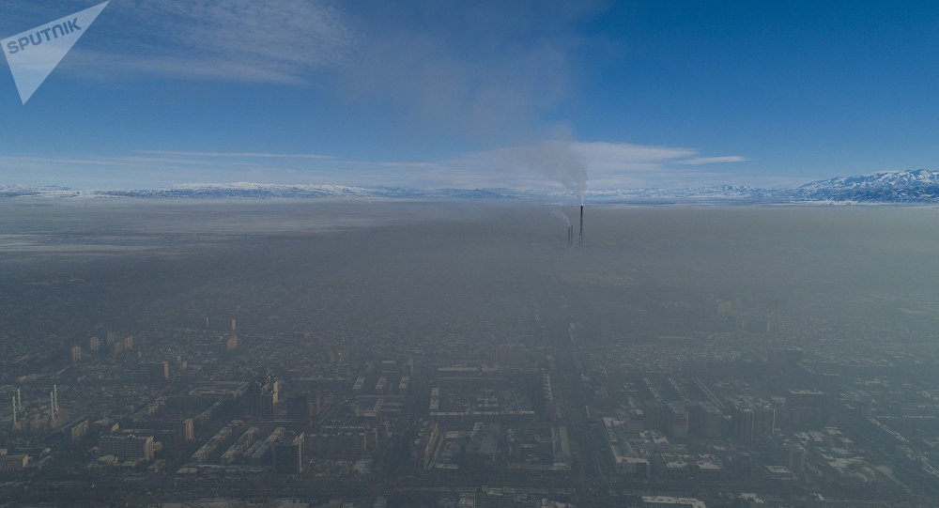

**Figure 4. Winter smog in Bishkek (taken from Sputnik.kg website)**

Coal consumption for heating by private households can be roughly estimated on the basis of the quantity of individual residential houses – 104 448 (according to the letter from the Mayor’s Office) and the average coal consumption by households – in the range from 2,6 tons (World Bank 2020) to approximately 3,27 tons (Camp Alatoo 2016). For our calculations we will use the mean between these two estimates – 2.935 tons per household. Based on the assumption that 85-90% of the private houses use coal as a major fuel, the approximate coal consumption by private sector in Bishkek during the heating season can be estimated to be around 266700 tons. Further, we used the weighted PM2.5 emission factor of 13.7 kg per ton of the bituminous coals (Champion et al, 2017). As a result, we came up to 3 654 tons of PM2.5 emissions into the air in Bishkek during the heating season from the private households. It should be noted, however, that the emission factor for Karakeche coal could significantly differ from the one referenced above. Thus, according to a recent Russian study (OAO MNIIECO, 2014) the emission factor of the brown coal with similar to Karakeche properties (humidity around 20% and calory content of 4240 Kcal per kg) could be as high as 68 kg per ton of the burnt coal.

To estimate emissions from vehicles we took the NSC statistics on the number of private cars in Bishkek in 2019 – 324 200 units. One of the main methods for evaluation of PM2.5 emissions from the road transport is based on using of emission factors for vehicle per kilometer driven. We used the emission factor of 0,02 g per vehicle per kilometer (Ferm and Sjoberg, 2015). The approximate mileage of Bishkek drivers was estimated to be around 175 km per week based on survey conducted by AUCA students (see the summary table in the Annexes). Further calculations brought to the estimated PM2.5 emissions from private vehicle to be around 29.5 tons during the period from October till March. This figure seems to be very understated, but on the other hand it provides a good insight into the potential contribution of the transport sector towards PM2.5 pollution in Bishkek.

Vehicle emissions in the Kyrgyz Republic are regulated by the Customs Union requirements, and in particular by a specific Technical Order #018 (Customs Union 2011). Annex#8 of this technical order lists specific requirements for vehicles:

**Table 7. The content of carbon monoxide in the exhaust gases of a vehicle with gasoline or gas engines**

|  |  |  |
| --- | --- | --- |
| Category and equipment of the vehicle (ecological class) | Engine speed | CO, by volume, % |
| M and N, not equipped with neutralization system for the exhaust gases | Minimal | 3,5 |
| Elevated | 2,0 |
| M and N, equipped with neutralization system for the exhaust gases (ecological classes 2 and lower) | Minimal | 0,5 |
| Elevated | 0,3 |
| M and N, equipped with neutralization system for the exhaust gases (ecological classes 3 and higher) | Minimal | 0,3 |
| Elevated | 0,2 |

**Table 8. Smokiness of the exhaust gases of a vehicle with diesel engine**

|  |  |
| --- | --- |
| For engines of ecological class 3 and lower | |
| For engines with turbine | 2,5 |
| For engines without turbine | 3,0 |
| For engines of ecological class 4 and above | 1,5 |

As it is seen from the above tables, the scope of vehicle pollutants subject to control in the Kyrgyz Republic is very limited. Unlike Europe and other developed countries, in Kyrgyzstan, as well in other Eurasian Economic Union countries there is a specific emission requirement for vehicles without catalytic converters. The laboratories implementing the technical inspection of the road transport check only the carbon monoxide content in the exhaust of the gasoline-powered cars, and smokiness level of the exhaust in the diesel-powered vehicles. Other major transport-related pollutants, such as NOx, Particulate Matter, Hydrocarbons are not regulated. Moreover, diesel-powered vehicles are not checked for specific pollutants at all. It is important to highlight that diesel vehicles were responsible for 97% of the PM2.5 exhaust emissions from road traffic and 90% of the NOx emissions in Europe (Harrison 2017).

Analysis of the data from one of the Bishkek-based laboratories (see relevant table in Russian in the Annexes) shows that 58% out of 76 vehicles tested exceeded the requirements set in the country for exhaust gases. The most critical factor leading to the increased air pollution from vehicles seems to be the absence of the catalytic converters, as all 36 vehicles lacking the converters failed to comply with the set target values. Interestingly, lack of converters had a much stronger effect for petroleum-powered vehicles (3.76 for cars with converters, and 0.48 for cars without a converter) than for diesel-powered vehicles (5.16 and 1.92 respectively).

Local expert in the field of technical inspection of cars in Bishkek that was interviewed during our field work estimated that at least 30% of the gasoline vehicles in the country do not have catalytic converters. For diesel vehicles this figure is at least 60%, as some categories of the vehicles are not equipped by catalytic converters by producers (e.g. Kamaz trucks) or have intentionally dismantled converters (e.g. Mercedes minibuses). In a survey conducted by AUCA students 63 out of 100 vehicle drivers (mainly passenger car drivers were interviewed) confirmed the presence of the catalytic converter. It is also worth to mention that one of the international studies found that catalytic converters reduce number of particles emitted from gasoline vehicles by 65% (Whelan 2013).

What are the economic costs of air pollution in Bishkek?

The researchers find that there is a casual link between income per capita and emission per capita. In case of Kyrgyzstan, this is true as well, so the increasing incomes cause the increase of consumption that leads to higher emissions levels. For instance, a wealthier family builds a new house or extends the existing one so the demand for heating grows.

The literature shows that lifestyle and structure of the population are major drivers (Das & Paul, 2014). The lifestyle factors, for instance, are recreation and housing. For example, high awareness of the climate change can lead to the household’s decisions that reduce the CO2 emissions regardless of the income. For example, a wealthier family invests more in energy efficient housing so contrary to the conventional wisdom, the increasing income leads to a lower emission. However, today we do not have any reliable knowledge about the interaction between climate change awareness and household behavior patterns in Kyrgyzstan

In recent years, the coal consumption by the households have been increasing. The major drivers of this increase include income growth that leads to more new houses and also unreliability of the of the electricity supply (Sabyrbekov & Ukueva, 2019).

Kyrgyz Household Integrated Survey (KHIS)

The KIHS stared in 2003 and implemented by the National Statistics Committee. The KIHS is quarterly survey and covers about 5,000 households. The KIHS is the largest panel survey in the country. The sample of the KIHS is drawn using stratified two-stage random sampling, based on the results of the 1999 population census. The KIHS aims to measure consumption-based poverty in the country and collects detailed data on expenses and consumption by households.

**Figure 5. Total consumption of energy source by households by KIHS 2013 - 2019. Source: authors’ calculations**[1]

The data from KIHS shows the households use five main energy sources: wood, coal, dung, corn, diesel, brushwood and LPG. In period of 2013 – 2019 the quantities of brushwood and dung have declined, while the coal consumption increased (Figure 5). The total consumption of coal in 2013 was 67,137 centners and rose to 82,038 centners in 2019 (Table 9). So the consumption of coal increased by 22% in six years. Despite the highest quantities of brushwood and dung the energy content is low and their decreasing trend probably related to the income growth.

**Table 9. Total and mean consumption of energy products. Source: authors' calculations from KIHS**

|  |  |  |  |  |  |  |  |  |  |  |  |  |  |  |
| --- | --- | --- | --- | --- | --- | --- | --- | --- | --- | --- | --- | --- | --- | --- |
|  | **Total** | **Mean** | **Total** | **Mean** | **Total** | **Mean** | **Total** | **Mean** | **Total** | **Mean** | **Total** | **Mean** | **Total** | **Mean** |
| **Fuel type\Year** | **2013** | **2013** | **2014** | **2014** | **2015** | **2015** | **2016** | **2016** | **2017** | **2017** | **2018** | **2018** | **2019** | **2019** |
| Wood (m3) | 5,960 | 0.84 | 2,304 | 0.38 | 4,866 | 0.83 | 29,449 | 2.08 | 3,052 | 0.62 | 6,098 | 1.08 | 1,633 | 0.28 |
| Coal (centners) | 67,137 | 4.78 | 63,816 | 4.88 | 52,738 | 4.09 | 295,509 | 23.80 | 74,806 | 5.80 | 82,693 | 5.90 | 82,038 | 5.81 |
| Dung (kg) | 1,046,689 | 128.07 | 999,551 | 127.40 | 1,023,877 | 123.40 | 644,294 | 118.69 | 700,749 | 138.02 | 671,325 | 136.01 | 572,692 | 137.47 |
| Corn (kg) | 144,833 | 73.17 | 104,035 | 60.77 | 77,888 | 57.49 | 57,145 | 55.66 | 39,823 | 48.80 | 34,215 | 42.24 | 42,214 | 50.08 |
| Diesel (l) | 676 | 34.44 | 2,205 | 60.87 | 416 | 42.57 | 771 | 85.10 | 1 | 0.50 | 10 | 5.00 | 5 | 1.13 |
| Brushwood (kg) | 874,565 | 61.97 | 878,298 | 55.72 | 894,204 | 57.27 | 651,372 | 56.22 | 632,804 | 59.76 | 704,333 | 64.82 | 633,338 | 60.78 |
| Gas ballon (kg) | 12,981 | 4.86 | 11,727 | 4.56 | 11,396 | 4.30 | 7,947 | 4.18 | 13,454 | 39.37 | 12,332 | 4.68 | 6,868 | 4.48 |

The coal-based CO2 emissions per household in 2013 were 3,241 kg and reached 3,958 kg in 2019 (Table 10). The KIHS does not report the calorific value nor where the coal was purchases, so we used a general 2.42kg CO2 output level per 1 kg of burned coal.

**Table 10. Coal consumption and emissions. Source: authors' calculations based on KIHS**

|  |  |  |  |  |  |  |  |
| --- | --- | --- | --- | --- | --- | --- | --- |
|  | **2013** | **2014** | **2015** | **2016** | **2017** | **2018** | **2019** |
| Total coal (kg) | 6,713,686 | 6,381,628 | 5,273,837 | 7,984,575 | 7,480,595 | 8,269,317 | 8,203,813 |
| Total CO2 emissions (kg) | 16,247,120 | 15,443,540 | 12,762,686 | 19,322,672 | 18,103,040 | 20,011,747 | 19,853,227 |
| Per household coal use | 1,339 | 1,275 | 1,051 | 1,592 | 1,491 | 1,649 | 1,636 |
| Per household emissions | 3,241 | 3,085 | 2,544 | 3,853 | 3,609 | 3,990 | 3,958 |
| Number of households | 5013 | 5006 | 5016 | 5015 | 5016 | 5016 | 5016 |

**Figure 6. Per household CO2 emissions from coal consumption. Source: authors' calculations based on the KIHS data**

The time-series data from KIHS shows that the emissions from coal consumptions dipped in 2015 to increase and the rising trend was stable in the recent years (Figure 6).

## Cost of Air Pollution

Polluted air has significant economic costs. In 2015 WHO estimated that the cost of premature death and disability from air pollution in Europe is close to USD 1.6 trillion (WHO Regional Office for Europe OECD, 2015). The latest macroeconomic studies in Europe show that increase in PM 2.5 concentration leads to decrease in real GDP due to reduction of labour productivity (Dechezleprêtre, Rivers, & Stadler, 2019). The immediate effects of the air pollution on the economy can be traced through increase of mortality and migration; reduction of hours worked per worker due to absenteeism; reduction of productivity to worsening cognitive abilities; decreasing productivity of natural ecosystems. Moreover, the evidence shows that high levels of air pollution are associated with higher crime rates and unethical behavior (Lu, 2020).

Therefore, the economic appraisal is a key part of the decision-making process for policymakers to develop sustainable policy measures. The standard measure of air pollution cost is done using the Value of Statistical Life (VSL). The VSL measures the reduction cost of the mortality risk, specifically it is calculated from an individual's willingness to pay for decrease in mortality risk and then the number is averaged over the population. The VSL has been estimated and available in many high-income countries.

The economic model of VSL is based on changes of utility in relation to changes of probability of dying.

$U=p*u_{m}\left(w\right)+\left(1-p\right)*u_{s}\left(w\right) \left(1\right)$

where $U$ is indirect utility, $p$ is the probability of mortality risk in the period, $u_{m}\left(w\right)$ is the utility of wealth if the person dies in the current period, and $u_{s}\left(w\right)$ is the utility of wealth if the individual survives within the period. The detailed introduction into the model is available in (Hammitt, 2000). The VSL is widely used in cost-benefit analysis for policy assessment of air pollution reduction measures (Robinson, Hammitt, & O’Keeffe, 2019). The standard steps of the cost-benefit analysis include eight major steps.

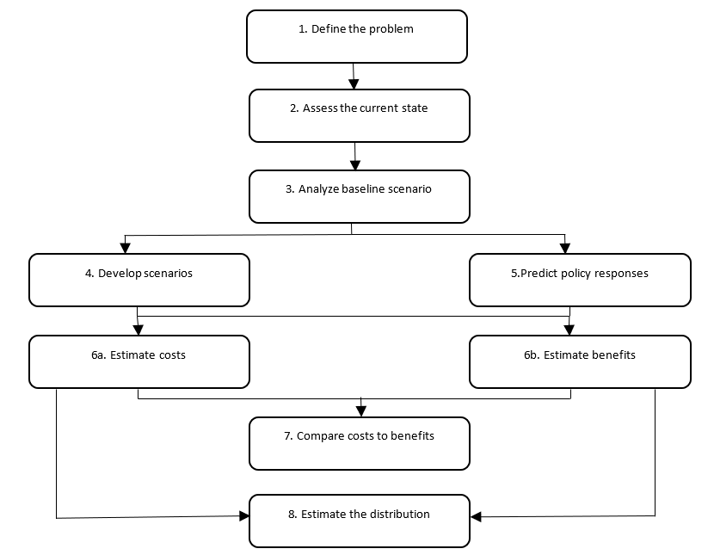

**Figure 7. Steps in cost-benefit analysis. Adapted from Robinson, Hammitt, & O’Keeffe (2019)**

Typically, in air pollution reduction strategies the VSL is used to assess damage caused by current levels of pollution (step 2 and 3 in Figure 7). After the assessment is complete, the VSL estimates can be used to calculate costs and benefits of the proposed policy options (steps 6a and 6b in Figure 7).

Economic cost of air pollution in Bishkek

To this date there have been no estimates of the economic cost of air pollution in Kyrgyzstan. Therefore, this is the first study to calculate the air pollution cost. Unfortunately, as many low-income countries, the Kyrgyz Republic does not have an official VSL number for the national cost-benefit studies. Ideally, we would like to observe the individual preferences for risk reduction in Kyrgyzstan using field studies. However, due to the project resources and epidemiological situation is not realistic.

Therefore, the value-transfer is used from high-income countries to low-income countries while correcting for income level. The value transfer formula is below

${VSL}_{KG}= {\left(\frac{{GDP per capita}_{KG}}{{GDP per capita }_{HIC}}\right)}^{e}* {VSL}_{HIC}$ (2)

where ${VSL}_{KG}$ is VSL in Kyrgyzstan and HIC variables are parameters of a high-income country. The e is income elasticity. VSL based on the U.S. uses elasticity of 1.5 while the OECD based studies use elasticity of 1.0 and the literature suggest that the mean elasticity is 1.5 with median of 1.4 (Robinson, Hammitt, Cecchini, et al., 2019).

Before the VSL could be estimated we must make sure that the GDPs are inflation adjusted, i.e. use the same currency base year for both countries. GDP deflator or a consumer price index (CPI) are widely used tools. For purposes of this study we use numbers based on constant 2010 USD (see Table 11).

**Table 11. Calculation of VSL for Kyrgyzstan**

|  |  |
| --- | --- |
| GDP per capita KG in 2019 (constant 2010 USD) | 1,116.358 |
| GDP per capita US in 2019 (constant 2010 USD) | 55,753.144 |
| Elasticity | 1.5 |
| VSL USA | 10,000,000 |
|  |  |
| VSL Kyrgyzstan | $28,333 |

**Table 12. VSL-based annual air pollution cost from number of deaths**

|  |  |  |  |  |
| --- | --- | --- | --- | --- |
| PM2.5 Annual Average Exposure Concentration | 32.8 µg/m3 | | 70 µg/m3 | |
| Population Risk or estimated number of deaths | 1,162 | 1,081 | 1,819 | 1,772 |
| VSL-based annual air pollution cost | 32,923,467 | 30,628,458 | 51,538,543 | 50,206,871 |

This is an example of the standard VSL which does not differentiate age groups. Another approach is the use of the value of statistical life-year (VSLY), which adjusts for the age.

$$VSLY={VSL/Life_expectancy}^{} (3)$$

The national life expectancy in Kyrgyzstan for 2020 year was 71.5 years. Based on the above data we can estimate that VSLY = $396. Considering that the population of Bishkek and Kyrgyzstan in general is young, then we expect that the value will be higher if VSLY is used in contrast with the use of VSL. As we get the age-detailed population census data for Bishkek, we can accurately estimate the VSLY.

The presented above VSL-based costs have to be treated with caution since it is based on the mortality risk which was derived from available data on PM concentrations. While we do not expect the drastic changes, we realize that as we get more data from remaining sensors the costs may change. Moreover, the economic cost of the air pollution is undervalued because the VSL-based cost does not account for the morbidity and labor productivity loss.

# **Conclusions**

Analysis of the extreme pollution events in Bishkek during the observed period showed that the impact of the climatic conditions on air pollution level in Bishkek is very significant. In 2019 there were registered 4 cases of extreme air pollution (all in December), in 2020 there were 5 (also in December), and in 2021 there were 40 cases (all in January). All 49 considered winter cases of abnormally high PM2.5 concentration recorded by the USA Embassy sensor since February 2019 were shortly preceded by temperature inversion events in Bishkek.

Another finding is that before those extreme pollution events there were also observed cases of snow/rain/fog. Interestingly, there was no snow or rain before the “dirtiest” week on record in the first decade of January 2021, but there were documented multiple occasions of fog occurrence in the beginning of January. We also noticed that beginning of January 2021 was a period of high atmospheric pressure which signals presence of the strong anticyclone.

Precise quantification of the PM pollution is very difficult and expensive exercise. Furthermore, even upon rigorous research the uncertainty level still could be very high. For example, one UK study reported the uncertainty of PM2.5 emissions calculations to be around 50% (AQEG 2012). Therefore, it makes sense to look at PM apportionment results in other countries in order to better understand the general situation with air pollution sources in Bishkek. Figures 8 and 9 below show the main sources of PM2.5 emissions in Europe and USA.



**Figure 8. PM2.5 emissions in the EU: share by sector group (source: EEA 2021)**

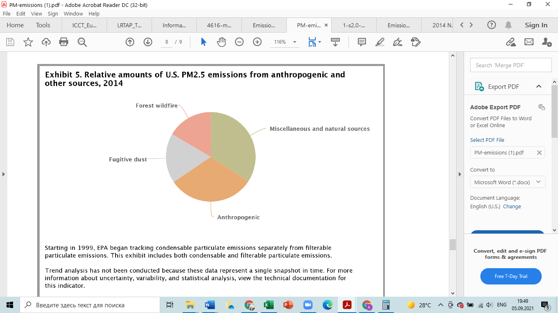

**Figure 9. Relative PM2.5 emissions in USA (source: US EPA 2018b)**

As we see from Figure 8, households contribute most to the PM2.5 total emissions in Europe. Taking into account that winter temperatures in Bishkek are significantly lower, and that households supposedly combust much more coal than in Europe, and that energy efficiency of local heating stoves is rather low, we can reasonably assume that in Bishkek the contribution of households could be even higher than in Europe. Interestingly, as Figure 9 shows, anthropogenic sources are not a dominating factor in total PM2.5 emissions in the United States, on the contrary, non-anthropogenic sources constitute the largest share by far. Based on the inventories of air pollution in other countries and approximate quantification of the major PM2.5 sources in Bishkek, we came up to the following estimates:

* The source contributing most to anthropogenic PM2.5 pollution in Bishkek during the average heating season is “Households and other buildings not connected to CHP”;
* Next most important source is CHP. However, it is difficult to estimate how much CHP contributes to the PM2.5 levels in Bishkek without detailed information on the effectiveness of the emission control system installed at the plant;
* Third most important source of the PM2.5 winter pollution is road transport.

The economic cost of air pollution section looked at the consumption of the energy products using the KIHS data and calculated the coal-based CO2 emissions by households. The Kyrgyz households emit high number of CO2 when burning coal.

The coal-based emission has increased by 22% in last six years. The coal consumption has been increasing and the data shows that this growth trend has been stable. Moreover, now we do not have more detailed information about the used coal and such important data as calorific value is missing.

# **Bibliography**

Air Quality Expert Group (AQEG). (2012). Fine Particulate Matter (PM2.5) in the United Kingdom. Retrieved from <https://uk-air.defra.gov.uk/assets/documents/reports/cat11/1212141150_AQEG_Fine_Particulate_Matter_in_the_UK.pdf> ;

Camp Alatoo PF. (2016). Baseline report ‘Assessment of households’ stoves and heating strategies in Osh, Jalalabad, Naryn and Chui oblasts’, Bishkek, 2016;

Champion W.M., Connors L., Montoya, L.D. (2017) Emission factors of fine particulate matter, organic and elemental carbon, carbon monoxide, and carbon dioxide for four solid fuels commonly used in residential heating by the U.S. Navajo Nation, Journal of the Air & Waste Management Association, 67:9, 1020-1035, DOI: [10.1080/10962247.2017.1334717](https://doi.org/10.1080/10962247.2017.1334717);

Customs Union. (2011). “Технический регламент ТР ТС 018/2011 - О безопасности колесных транспортных средств“. Retrieved from <http://nism.gov.kg/assets/tr_ts_018-2011_text.pdf>

Das, A., & Paul, S. K. (2014). CO2 emissions from household consumption in India between 1993-94 and 2006-07: A decomposition analysis. Energy Economics, 41, 90–105. <https://doi.org/10.1016/j.eneco.2013.10.019>;

Dechezleprêtre, A., Rivers, N., & Stadler, B. (2019). The economic cost of air pollution: Evidence from Europe. OECD Economic Department Working Papers, (1584), 0_1-62.

Encyclopedia Britannica, online encyclopedia, Britannica.com, accessed in August 2021

European Environment Agency. (2021). European Union emission inventory report 1990-2019

under the UNECE Convention on Long-range Transboundary Air Pollution (Air Convention), Luxembourg. doi:10.2800/701303;

Ferm M., Sjoberg, K.. (2015). ‘Concentrations and emission factors for PM2.5 and PM10 from road traffic in Sweden’, Atmospheric Environment 119;

Hammitt, J. K. (2000). Valuing mortality risk: Theory and practice. Environmental Science and Technology, 34(8), 1396–1400. <https://doi.org/10.1021/es990733n>

Harrison, R.M., Beddows, D.C. (2017). Efficacy of Recent Emissions Controls on Road Vehicles in Europe and Implications for Public Health. *Sci Rep* **7,**1152

<https://doi.org/10.1038/s41598-017-01135-2>.

Isaenko P. (2021). How smog overfilled the Chuy valley in winter of 2020-2021. Retrieved in August 2021 from <https://pavel-isayenko.medium.com/>;

# Kulenbekov, Zh. et al. (2016). Atmospheric Air Quality Assessment of Bishkek City as an Indicator of Sustainable Development. Vestnik of Sesmology Institute under Kyrgyz National Academy of Sciences. 2(8) pp. 36-45. УДК: 502/504. eLIBRARY ID: 29273735;

Lu, J. G. (2020). Air pollution: A systematic review of its psychological, economic, and social effects. Current Opinion in Psychology, 32, 52–65. <https://doi.org/10.1016/j.copsyc.2019.06.024>

Movegreen PA. (2021a). Seasonal Report on Air Quality in Bishkek for Winter 2020-2021. Retrieved in August 2021 from [movegreen.kg](http://movegreen.kg/);

Movegreen PA. (2021b). Data Analysis for 3 years. Retrieved in August 2021 from [movegreen.kg](http://movegreen.kg/);

National Statistics Committee of the Kyrgyz Republic. (2020). Statistical Digest “Population Health and Healthcare in the Kyrgyz Republic, 2015-2019”. Retrieved in August 2021 from <http://stat.kg/ru/publications/sbornik-zdorove-naseleniya-i-zdravoohranenie-v-kyrgyzskoj-respublike/>

OAO MNIIECO. (2014). “Отраслевая методика расчета количества отходящих, уловленных и выбрасываемых в атмосферу загрязняющих веществ при сжигании угля и технологических процессах горного производства на предприятиях угольной промышленности”, Perm.

Perova M.V. (2013).Temperature regime during cold half of a year and climatic parameters of the heating season at the territory of the Northern, North-Western Kyrgyzstan. Bishkek, KRSU;

Podrezov O.A., Podrezov A.O., Riazanov V.E. (2018). Bishkek city atmospheric air pollution in the winter season of 2017-2018. Vestnik KRSU, 18/12, 2018;

Robinson, L. A., Hammitt, J. K., Cecchini, M., Chalkidou, K., Cropper, M., Hoang, P., … Wilkinson, T. (2019). Reference Case Guidelines for Benefit ‐ Cost Analysis in Global Health and Development, (May), 101. Retrieved from <https://cdn1.sph.harvard.edu/wp-content/uploads/sites/2447/2019/05/BCA-Guidelines-May-2019.pdf>

Robinson, L. A., Hammitt, J. K., & O’Keeffe, L. (2019). Valuing Mortality Risk Reductions in Global Benefit-Cost Analysis. Journal of Benefit-Cost Analysis, 10, 15–50. <https://doi.org/10.1017/bca.2018.26>

Sabyrbekov, R., & Ukueva, N. (2019). Transitions from dirty to clean energy in low-income countries: insights from Kyrgyzstan. Central Asian Survey, 0(2), 1–20. <https://doi.org/10.1080/02634937.2019.1605976>

United States Environmental Protection Agency. (2018). Technical Assistance Document for the Reporting of Daily Air Quality – the Air Quality Index (AQI). EPA 454/B-18-007, 2018;

United States Environmental Protection Agency. (2018). 2014 National Emissions Inventory, version 2, Technical Support Document;

Whelan, I., Timoney, D., Smith, W., and Samuel, S. (2013). The Effect of a Three-Way Catalytic Converter on Particulate Matter from a Gasoline Direct-Injection Engine During Cold-Start. SAE Int. J. Engines 6(2):1035-1045. <https://doi.org/10.4271/2013-01-1305>.

WHO Regional Office for Europe OECD. (2015). Economic cost of the health impact of air pollution in Europe: Clean air, health and wealth. Copenhagen.

# WHO. (2016). Ambient air pollution: A global assessment of exposure and burden of disease.

World Bank. (2020). Fueling Kyrgyzstan’s transition to clean household heating solutions. Retrieved from <https://openknowledge.worldbank.org/bitstream/handle/10986/33833/Fueling-Kyrgyzstan-s-Transition-to-Clean-Household-Heating-Solutions.pdf?sequence=1&isAllowed=y>

Zhang X. (2016). Emission standards and control of PM2.5 from coal-fired power plant. IEA Clean Coal Centre;

# **Annexes**

Part of the survey results table among Bishkek drivers.

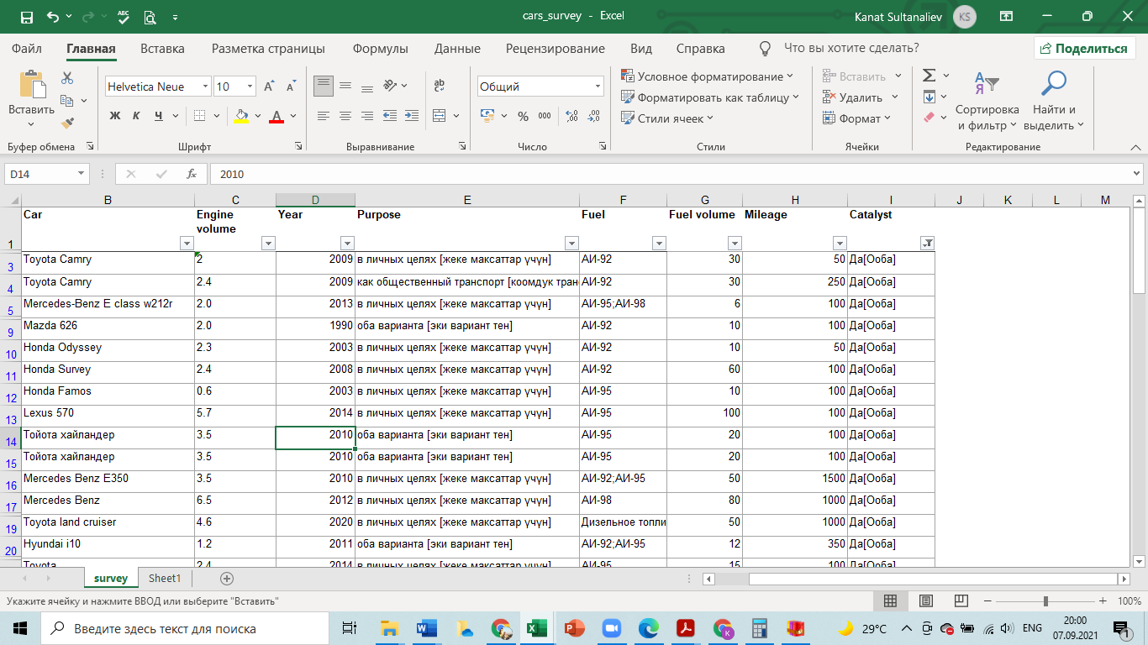

|  |  |  |  |  |  |  |
| --- | --- | --- | --- | --- | --- | --- |
|  | *Данные для исследования по качеству воздуха (для АУЦА).* | | | | | |
|  |  |  |  |  |  |  |
| **Марка авто** | **Год производства** | **Вид топлива** | **Обьем двигателя** | **Показатели по выхлопам, СО** | **Показатели по дымности** | **Наличие катализатора** |
| Toyota Camry | 2013 | Бензин | 2500 | 0,3 |  | Да |
| Toyota Camry | 2016 | Бензин | 2500 | 0,2 |  | Да |
| Toyota Camry | 2013 | Бензин | 2500 | 0,4 |  | Да |
| Toyota Camry | 2011 | Бензин | 2500 | 0,3 |  | Да |
| Toyota Camry | 2014 | Бензин/ Гибрид | 2500 | 0,1 |  | Да |
| Toyota Camry | 2013 | Бензин/ Гибрид | 2500 | 0,2 |  | Да |
| Toyota Camry | 2003 | Бензин | 2400 | 0,7 |  | Да |
| Toyota Camry | 2005 | Бензин | 2400 | 0,8 |  | Да |
| Toyota Camry | 2001 | Бензин | 3000 | 0,7 |  | Да |
| Toyota Camry | 2003 | Бензин | 2400 | 0,9 |  | Да |
| Toyota Camry | 2010 | Бензин | 2500 | 4 |  | Нет |
| Toyota Camry | 2002 | Бензин | 2400 | 4,9 |  | Нет |
| Toyota Camry | 2004 | Бензин | 2400 | 4,7 |  | Нет |
| Toyota Camry | 2011 | Бензин | 2400 | 3,8 |  | Нет |
| Toyota Camry | 2002 | Бензин | 2400 | 3,9 |  | Нет |
| Toyota Camry | 2005 | Бензин | 2400 | 4,1 |  | Нет |
| Toyota Camry | 2014 | Бензин | 2500 | 3,7 |  | Нет |
| Mersedes-Benz, Бус | 2008 | Дизель | 2200 |  | 2,4 | Да |
| Mersedes-Benz, Бус | 2006 | Дизель | 2970 |  | 2,1 | Да |
| Mersedes-Benz, Бус | 2009 | Дизель | 2200 |  | 2 | Да |
| Mersedes-Benz, Бус | 2002 | Дизель | 2148 |  | 3,2 | Да |
| Mersedes-Benz, Бус | 2002 | Дизель | 2148 |  | 2,3 | Да |
| Mersedes-Benz, Бус | 2010 | Дизель | 2148 |  | 1,9 | Да |
| Mersedes-Benz, Бус | 2008 | Дизель | 2970 |  | 1,6 | Да |
| Mersedes-Benz, Бус | 2007 | Дизель | 2148 |  | 2,3 | Да |
| Mersedes-Benz, Бус | 2006 | Дизель | 2148 |  | 4,4 | Да |
| Mersedes-Benz, Бус | 2001 | Дизель | 2148 |  | 2,6 | Да |
| Mersedes-Benz, Бус | 2010 | Дизель | 2148 |  | 3,7 | Нет |
| Mersedes-Benz, Бус | 2002 | Дизель | 2874 |  | 4,6 | Нет |
| Mersedes-Benz, Бус | 1998 | Дизель | 2874 |  | 4,9 | Нет |
| Mersedes-Benz, Бус | 1996 | Дизель | 2299 |  | 5,2 | Нет |
| Mersedes-Benz, Бус | 2007 | Дизель | 2148 |  | 4,6 | Нет |
| Mersedes-Benz, Бус | 2009 | Дизель | 2148 |  | 4,3 | Нет |
| Mersedes-Benz, Бус | 2011 | Дизель | 2148 |  | 4,3 | Нет |
| Mersedes-Benz, Бус | 1999 | Дизель | 2874 |  | 5,2 | Нет |
| Mersedes-Benz, Бус | 2000 | Дизель | 2148 |  | 4,7 | Нет |
| Mersedes-Benz, Бус | 1992 | Дизель | 2299 |  | 5,9 | Нет |
| Lexus, GX | 2005 | Бензин | 4700 | 0,6 |  | Да |
| Lexus, GX | 2008 | Бензин | 4700 | 0,3 |  | Да |
| Lexus, GX | 2008 | Бензин | 4700 | 0,3 |  | Да |
| Lexus, GX | 2004 | Бензин | 4700 | 0,5 |  | Да |
| Lexus, GX | 2006 | Бензин | 4700 | 0,5 |  | Да |
| Lexus, GX | 2008 | Бензин | 4700 | 0,3 |  | Да |
| Lexus, GX | 2005 | Бензин | 4700 | 0,6 |  | Да |
| Lexus, GX | 2005 | Бензин | 4700 | 0,4 |  | Да |
| Lexus, GX | 2003 | Бензин | 4700 | 0,6 |  | Да |
| Lexus, GX | 2009 | Бензин | 4700 | 0,2 |  | Да |
| Lexus, GX | 2005 | Бензин | 4700 | 2,2 |  | Нет |
| Lexus, GX | 2003 | Бензин | 4700 | 2,5 |  | Нет |
| KAMAZ | 1992 | Дизель | 10850 |  | 6 | Нет |
| KAMAZ | 1999 | Дизель | 10850 |  | 5,6 | Нет |
| KAMAZ | 1994 | Дизель | 10850 |  | 5,8 | Нет |
| KAMAZ | 1996 | Дизель | 10850 |  | 6,2 | Нет |
| KAMAZ | 2001 | Дизель | 11760 |  | 4,8 | Нет |
| KAMAZ | 2001 | Дизель | 11760 |  | 4,6 | Нет |
| KAMAZ | 1998 | Дизель | 10850 |  | 5,5 | Нет |
| KAMAZ | 1991 | Дизель | 10850 |  | 6,4 | Нет |
| KAMAZ | 1991 | Дизель | 10850 |  | 5,8 | Нет |
| KAMAZ | 1996 | Дизель | 10850 |  | 6,3 | Нет |
| KAMAZ | 1999 | Дизель | 10850 |  | 5,1 | Нет |
| KAMAZ | 2005 | Дизель | 11760 |  | 3,9 | Нет |
| KAMAZ | 2005 | Дизель | 11760 |  | 3,3 | Нет |
| KAMAZ | 1994 | Дизель | 10850 |  | 5,9 | Нет |
| KAMAZ | 1992 | Дизель | 10850 |  | 6,1 | Нет |
| KAMAZ | 1998 | Дизель | 10850 |  | 5,4 | Нет |
| KAMAZ | 1998 | Дизель | 10850 |  | 5,2 | Нет |
| VOLVO | 2013 | Дизель | 12780 |  | 1,8 | Да |
| VOLVO | 2013 | Дизель | 12780 |  | 1,3 | Да |
| VOLVO | 2015 | Дизель | 12780 |  | 0,9 | Да |
| VOLVO | 2005 | Дизель | 12777 |  | 2,1 | Да |
| VOLVO | 2013 | Дизель | 12780 |  | 1,2 | Да |
| DAF | 2013 | Дизель | 12900 |  | 1.2 | Да |
| DAF | 2013 | Дизель | 12900 |  | 1,4 | Да |
| DAF | 2014 | Дизель | 12900 |  | 1,2 | Да |
| DAF | 2015 | Дизель | 12900 |  | 0,95 | Да |
| DAF | 2015 | Дизель | 12900 |  | 0,85 | Да |

Part of the Excel File with PM2.5 concentration downloaded from the US Embassy

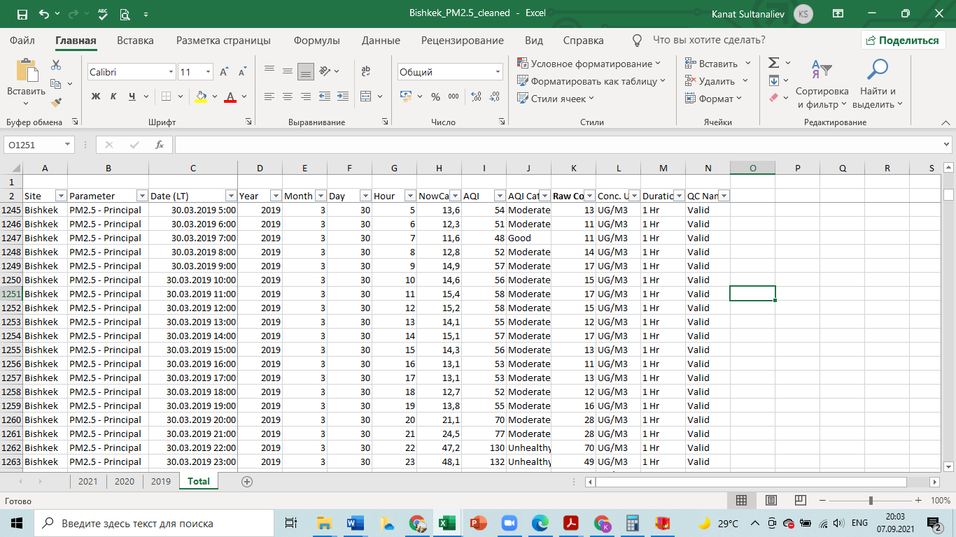

Part of the Excel File with climatic parameters on Bishkek

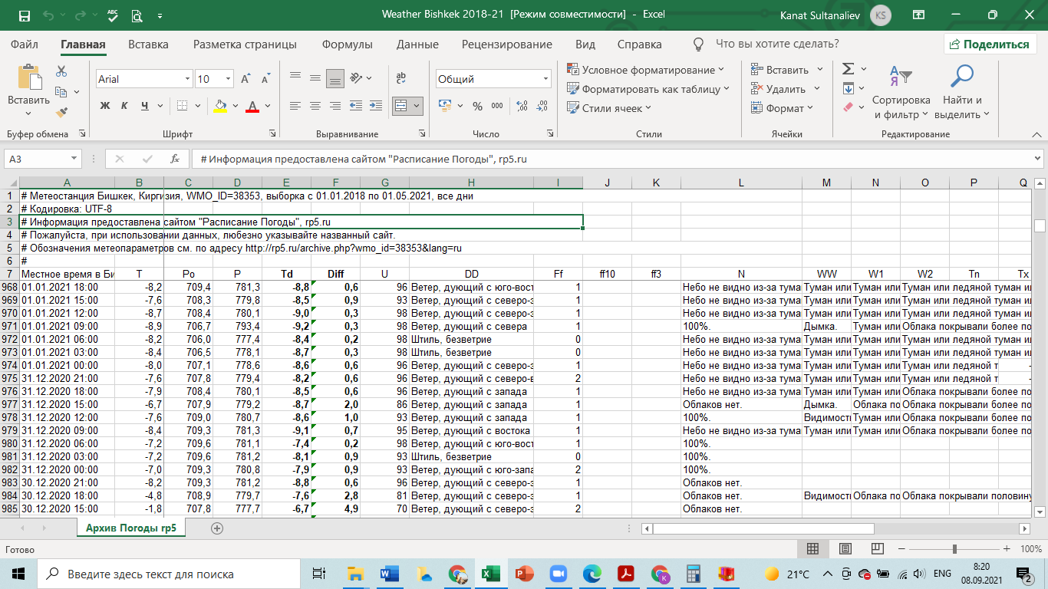

Часть анкеты

2. ЖИЛИЩНО-КОММУНАЛЬНЫЕ РАСХОДЫ

Сейчас я хотел (а) бы подробно записать все жилищно-коммунальные расходы относительно жилья, в котором Вы проживаете.

1. Были ли у Вас за прошедший квартал расходы на приобретение топлива и сжиженного газа или потребление на отопление и личные нужды? (сюда включаются приобретения в качестве подарка)

Да…………………………………………………………1

Нет………………………………………………………..2 ⇒ вопрос 2

* 1. Какие виды топлива Вы приобрели и как израсходовали?

|  |  |  |  |  |  |  |  |
| --- | --- | --- | --- | --- | --- | --- | --- |
| №/п | Вид топлива | | Какое количе  ство было куплено? | Стоимо  стьпоку  пок  (сомов) | Сколько было получено  в качест  ве  подарка? | Сколько загото  вили сами? (собрали сами, из запасов) | Какое количество было израсходовано на отопление и для приготовления пищи? |
| 1 | А | | 3 | 4 | 5 | 6 | 7 |
| 1 | Дрова  (куб.м) | В прошлом м-це |  |  |  |  |  |
| 2 | Два месяца назад |  |  |  |  |  |
| 3 | Три месяца назад |  |  |  |  |  |
| 4 | Уголь  камен  ный(ц) | В прошлом м-це |  |  |  |  |  |
| 5 | Два месяца назад |  |  |  |  |  |
| 6 | Три месяца назад |  |  |  |  |  |
| 7 | Торф  (кг) | В прошлом м-це |  |  |  |  |  |
| 8 | Два месяца назад |  |  |  |  |  |
| 9 | Три месяца назад |  |  |  |  |  |
| 10 | Керо  син  (л) | В прошлом м-це |  |  |  |  |  |
| 11 | Два месяца назад |  |  |  |  |  |
| 12 | Три месяца назад |  |  |  |  |  |
| 13 | Мазут  (л) | В прошлом м-це |  |  |  |  |  |
| 14 | Два месяца назад |  |  |  |  |  |
| 15 | Три месяца назад |  |  |  |  |  |
| 16 | Кизяк  (кг) | В прошлом м-це |  |  |  |  |  |
| 17 | Два месяца назад |  |  |  |  |  |
| 18 | Три месяца назад |  |  |  |  |  |
| 19 | Куку  рузное  буды  лье (кг) | В прошлом м-це |  |  |  |  |  |
| 20 | Два месяца назад |  |  |  |  |  |
| 21 | Три месяца назад |  |  |  |  |  |
| 22 | Соляр  ка  (л) | В прошлом м-це |  |  |  |  |  |
| 23 | Два месяца назад |  |  |  |  |  |
| 24 | Три месяца назад |  |  |  |  |  |
| 25 | Хво  рост  (кг) | В прошлом м-це |  |  |  |  |  |
| 26 | Два месяца назад |  |  |  |  |  |
| 27 | Три месяца назад |  |  |  |  |  |
| 28 | Балон-ный  сжиж.16  Газ (кг) | В прошлом м-це |  |  |  |  |  |
| 29 | Два месяца назад |  |  |  |  |  |
| 30 | Три месяца назад |  |  |  |  |  |
| 31 | КС (сумма строк 1-30) | |  |  |  |  |  |

1. *2016 is clear outlier, probably to data measurement misspecification*